► Have you or anyone you know been unusually ill this Winter? See: GassingAmerica.us
- HUD & Your State Bureaucracy may be the cause! or GassingNativeAmerica.us
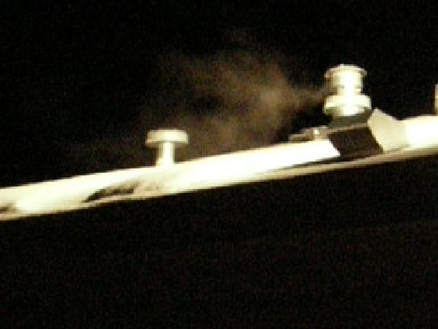
Has your State and the Feds with HUD, and their Medical contractors, including CPS (DCFS), the AG and their Courts, allowed conditions for your and your children's harm, then profited from your harm and your children’s consequent hurt, illnesses and damage -- even deaths?

Have you been placed in harms way by the very Bureaucracy whose oaths and claims are to guarantee your safety and to protect you and your children from the very harm which they have created and permitted?

Has that same Bureaucracy then instead, turned upon you, blamed you, threatened, charged or indicted you for the harm, illnesses, even deaths, which their oversight, incompetence, malfeasance or malice has brought upon you and your children? -- just as it has done with this baby Daniel and his parents in Manti, Utah!

► Please consider the above and following questions; see baby Daniel's experience;
find your own answers; then demand correction to protect your family!

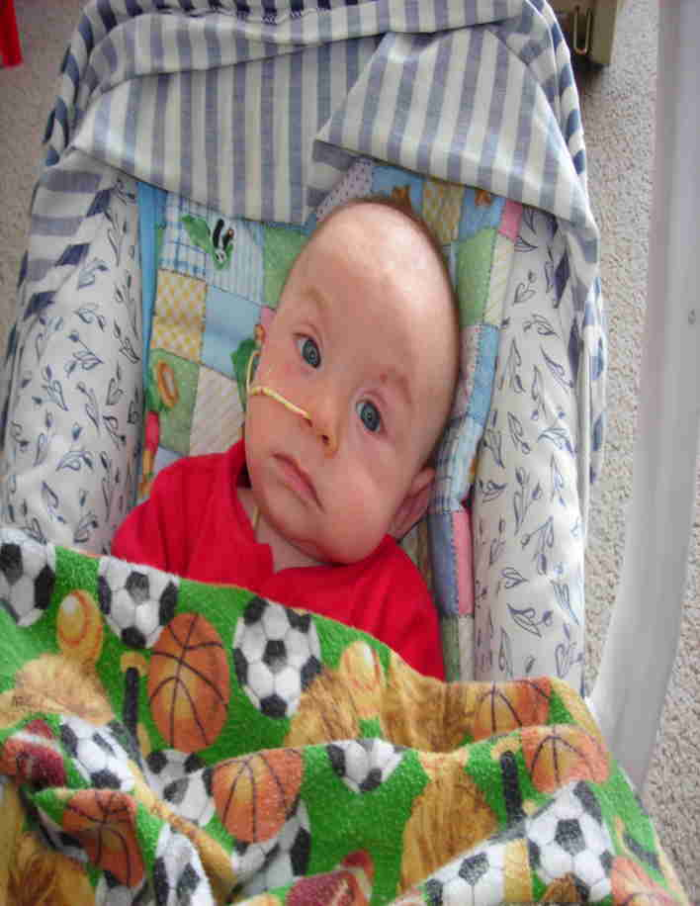
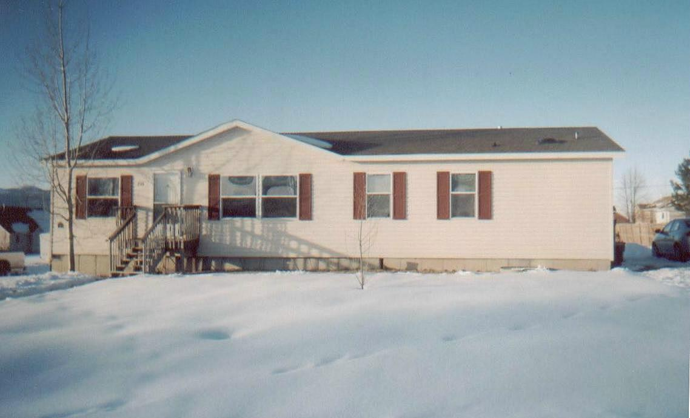
Do you or anyone you love or care about live in a heat retrofitted, or a HUD (or FEMA) "Certified as Safe" Manufactured, Modular, or Mobile home (Trailer)?

Did you or anyone you know have one or more of the following symptoms? Unexplained (chronic) fatigue, bouts of nausea, headaches, loss of memory, agitation, flu-like (but without fever) symptoms, rosacea (a red skin blush) or jaundice, general weakness, nose-bleeds, coughing spells (sometimes with blood) labored breathing, struggle for air, light headedness, lethargy, fainting spells, listlessness, inability to sleep soundly, loss of appetite, reduced fertility, reduced virility, fetal damage, unexplainable weight loss or gain, or unusual heart problems: angina, arrhythmia, myocarditis, infarction, etc (all are absolute expressions of CO - Carbon Monoxide induced hypoxia and intoxication).

► In Infants, any one of the symptoms above, and / or inconsolable crying (indicating headaches), inability to hold food down (nausea), inability to suckle (weakness), failure to thrive, and / or (misdiagnosed) symptoms of malnutrition, leukemia, diabetes, autoimmune, digestive, liver, heart, lung, neurological, endocrine or genetic disorders, etc. to "SIDS" and "crib death'' -- and since long term exposure can cause critical developing tissue failures, membrane (esp. cerebral) and vascular ruptures and associated hemorrhaging (hence sub-dermal, spontaneous bruising), some infant damages or deaths may be wrongly or falsely charged off as beatings, assault, even "shaken baby syndrome"!

Did you find any elderly or otherwise infirmed unusually listless, slowed, or unresponsive during the or at the end of winter, where they had been communicative, bright, or active prior? --
Do you know of any children, adolescents or adult who were healthy before, but became subtly to seriously ill as Winter commenced, deepened and progressed – then with warming weather (less furnace operation), they may have miraculously improved! -- or someone who did not make it though the Winter, yet should have! -- or who died for no solidly diagnosed reasons! --

-- Too often Carbon Monoxide victims are mis-diagnosed with leukemia, diabetes, malnutrition, vitamin B12 deficiency, depression, endocrine or genetic disorders, etc, etc, etc. even Munchausen by Proxy (it fits easily); then are expensively (futilely, even dangerously) treated into bankruptcy for those, when all that was really needed was a simple $40.00 (actual cost less than $5) Carboxyhemoglobin test, then prescribed the simple (and cheap) treatment of clean air, clean food and genuine care and love! -- none for which a Doctor, Hospital, the State, its Bureaucracy or their Lawyers can extravagantly charge and honestly profit!
-- And worse, the victims are returned to the same uncorrected toxic environment to repeat the illness cycle, establish more damage, even die!

► "Carbon monoxide is the leading cause of fatal poisoning in the industrialized world, as well as being endemic in many parts of the developing world," says Dr. Joseph Fisher, an anesthesiologist at Toronto General Hospital, University Health Network. "In North America, it results in as many as 70,000 emergency room visits a year and in thousands of deaths. Up to 30 per cent of survivors of severe poisoning are left with disabling psychological and neurological symptoms, which sometimes last for years."

-- How did HUD get away with setting their own minimum distance regulation at only 3 ft? While all others like the American Gas Association, National Association of Home Builders, most HVAC Manufacturers (under GAMA), and most State and Local Codes usually require 12 to 14 feet? The minimum I have found is 10 feet per ICC's International Mechanical Code. -- TLR

-- When you entered into your HUD home, did your State licensed Inspector alert you to your potentially lethal HUD created asphyxiation possibility? If he did not, why not? Ask his bosses (in “Those Who Know”, list on back) why not?

-- In last 10 minutes of 28 May 08 Radio interview, Utah AG Mark Shurtleff and I exposed this case and this problem.
Audio Utah Attorney General Mark Shurtleff interview (hr 2) by Mark Maxon on KTKK AM 630 SLC Ut

-- in last 30 min of the 3 hour Utah State Legislature's Political Subdivisions Interim Committee Wed 18 Jun 08 Meeting on Affordable Housing, I presented this case as example of HUD Manufactured Housing's Carbon Monoxide (& Formaldehyde) poisoning issue, as exposed herein. See Notice, see Agenda, hear Audio (mp3). – Linked on websites below. – TLR 6/24/08

► 65% of HUD certified homes, spc. manufactured homes & trailers in rural USA are occupied by Spanish families! Next are African American, specifically Hurricane Katrina victims, then Native Americans, the Elderly, Widowed, Veterans, Handicapped, Young and Single Mother Families, Missionaries, rural Clergy, County, State and Federal Field Agents, Rangers and Officers, and our selfless Military!
--- Yet no-one in HUD, Federal or State Bureaucracy, Medicine or Media, has cared enough to warn these precious families and these critical Service individuals that some of their Winter impairment, illnesses and deaths are a result of this egregious HUD created, State permitted deadly Furnace / Water Heater exhaust / Fresh Air Adder design! -- Why not??? – Questions: Tom R. 801-298-9095 -- over –

Legislative / Public Notice:
Re: GassingAmerica.us / DanielInTheLionsDen.us or GassingNativeAmerican.us & GassingUtah.us 15 Dec 09

On Feb 10 last year, 2008, a family in Manti Utah with an ill infant, and under DCFS threat, contacted me. The Doctor in their community did not identify the actual cause. The family knew I had experience dealing with the State and success in pediatric forensics and pathology. In 3 days, after they were referred to PCMC hospital locally, I was able to see the child and his parents. I realized by their appearance and behaviors that all three, the infant as well as the father and mother had been poisoned. In 6 days (during legislative weekend break) I was able to travel to their home. I discovered the family’s actual poisoning cause! -- Carbon Monoxide was entering their home!

There was nothing wrong with their furnace or any other combustion type appliance.
The source of their poisoning was a decades-ago Federal (with State and Medical complicity), “carefully deliberated”, HUD established and dictated construction and installation code (as a true lunacy), which allows exhaust fumes to easily enter back into their manufactured and mobile home units, when positioning and certain common, periodic or severe weather patterns exist.

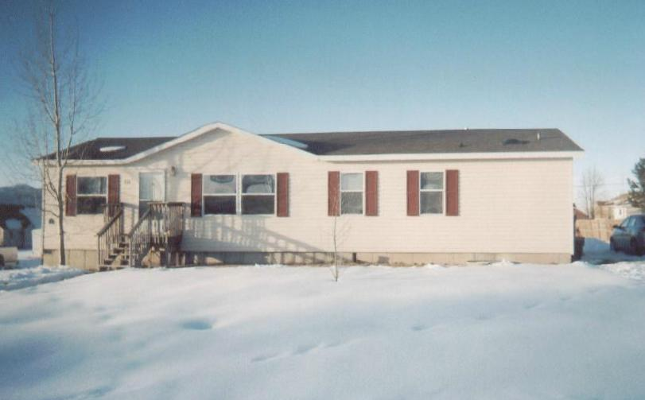
For 3 decades HUD has put at risk over 26 million residents as it has defied all other rational community building standards and code setting entities -- as well as ignoring well understood environmental and biological sensibility and fact, by allowing in Mobile and Manufactured homes, a separation distance of only 3 feet (as opposed to 12-14 ft) from a furnace, water heater, or sewer exhaust to a passive or power driven fresh air intake, aka “supplemental air”, “blend air”, or “Dilution air” intake vent. This “fresh” air intake was intended to compensate (via fan forced supplementation) for the oxygen consumption of the occupants inside these generally air-tight constructed and smaller total interior air volume situations extant in HUD designed, regulated and “inspected” Manufactured and Mobile home type units.

This poison-affected infant and his family’s home was one of those HUD “certified as safe” Manufactured / Mobile home type units -- just like those constructed and used to house and injure the Hurricane Katrina victims.

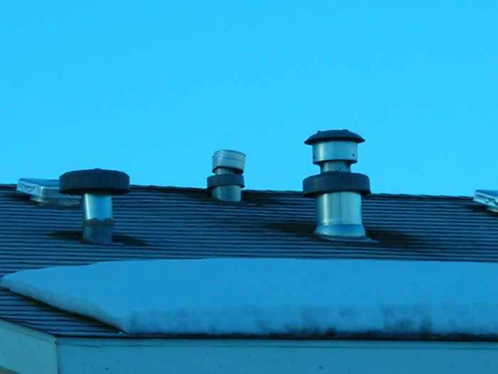You have heard the reports of the formaldehyde poisonings experienced by those occupants in those “Katrina” units. Through the poisoning discovery in this family’s case, I opened the far greater Pandora’s box of hidden and unidentified Carbon Monoxide (CO) injuries and deaths occurring in these offending units for nearly three decades at the malfeasant or incompetent regulatory hands of HUD (and now FEMA).

Locally and Nationally, millions of individuals living in these units have been unknowingly harmed by this design-created back-draft of toxic exhaust from their heating systems, especially in last and this current winter’s unusually severe cold and wind patterns. Still left uninformed they are subject to further harm and deaths in this winter’s already extant, continuing and further anticipated severities.

Sadly for twenty-two months I have been deliberately obstructed, stone-walled, denigrated, abused, threatened and injured, reputationally, professionally, politically, socially, economically, and ecclesiastically, by those invested with position and power that are unscrupulously benefited and profit from the unique cheap (often undocumented) labor supply, or from the struggling and vulnerable low income people who generally live in, or are housed (and as now understood, consequently made ill and left with injury) in these inexpensive – cheap to purchase, transport and set – “local inspection / local government entry exempt” HUD, Manufactured and Mobile Home type housing units.

Clearly no cheap-labor cheap-housing benefited businessmen, HUD (or FEMA), the Bureaucracy, their contractors, distributors, beneficiaries, or the opportunistic Medical community, want to have these millions of units investigated
– and have the often illegal nature of many of their occupants discovered – or their injuries disclosed – not even to let our own legitimate individuals and families living in them understand and be enabled to protest the injuries and deaths which they have experienced for over three decades, without ever being informed as to true cause – or to have the costly discovery, correction, litigation and recompense made for the tens to hundreds of thousands of their this-caused injuries and deaths. This is why you have heard NO disclosure from the Government, Medicine or Media.

Until Government acts, occupants must be informed and abled to protect self & family from this poisoning harm.
Learn at GassingAmerica.us or GassingNativeAmerica.us - videos, photos, documents on DanielInTheLionsDen.us

Thomas L Rodgers, Phone: 801-298-9095, LSI, PO Box 304, Bountiful, Utah, 84011 (email Tom@LifeSave.org)

