► Have you or anyone you know been unusually ill this Winter?
- HUD & Utah State Bureaucracy may be the cause! See -- GassingUtah.us
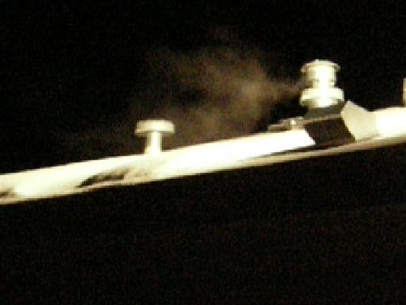
Has the State of Utah and the Feds with HUD, and their Medical contractors, including CPS (DCFS), the AG and their Courts, allowed conditions for your and your children's harm, then profited from your harm and your children’s consequent hurt, illnesses and damage -- even deaths?

Have you been placed in harms way by the very Bureaucracy whose oaths and claims are to guarantee your safety and to protect you and your children from the very harm which they have created and permitted?

Has that same Bureaucracy then instead, turned upon you, blamed you, threatened, charged or indicted you for the harm, illnesses, even deaths, which their oversight, incompetence, malfeasance or malice has brought upon you and your children? -- just as it has done with this baby Daniel and his parents in Manti, Utah!

► Please consider the above and following questions; see baby Daniel's experience;
find your own answers; then demand correction to protect your family!

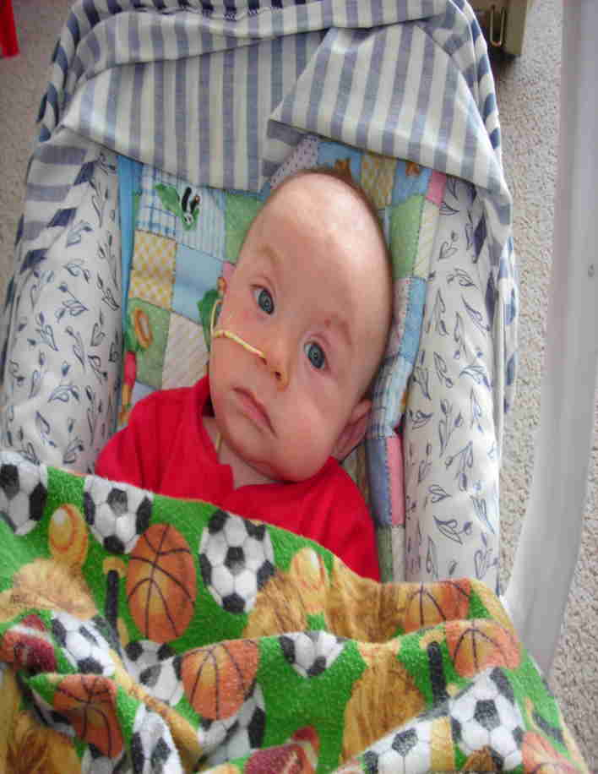
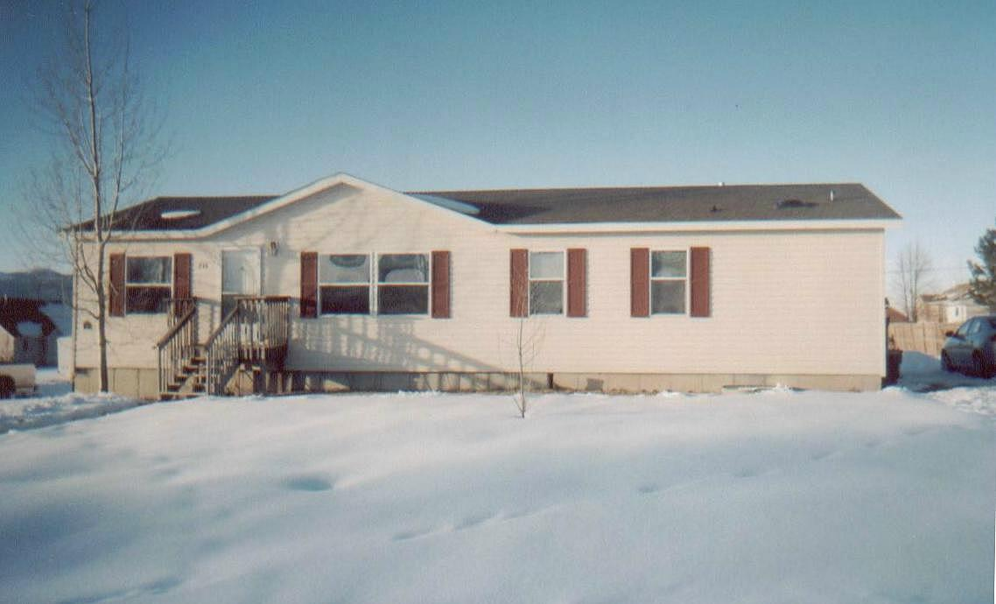
Do you or anyone you love or care about live in a heat retrofitted, or a HUD (or FEMA) "Certified as Safe" Manufactured, Modular, or Mobile home (Trailer)?

Did you or anyone you know have one or more of the following symptoms? Unexplained (chronic) fatigue, bouts of nausea, headaches, loss of memory, agitation, flu-like (but without fever) symptoms, rosacea (a red skin blush) or jaundice, general weakness, nose-bleeds, coughing spells (sometimes with blood) labored breathing, struggle for air, light headedness, lethargy, fainting spells, listlessness, inability to sleep soundly, loss of appetite, reduced fertility, reduced virility, fetal damage, unexplainable weight loss or gain, or unusual heart problems: angina, arrhythmia, myocarditis, infarction, etc (all are absolute expressions of CO - Carbon Monoxide induced hypoxia).
► In Infants, any one of the symptoms above, and / or inconsolable crying (indicating headaches), inability to hold food down (nausea), inability to suckle (weakness), failure to thrive, and / or (misdiagnosed) symptoms of malnutrition, leukemia, diabetes, autoimmune, digestive, liver, heart, lung, neurological, endocrine or genetic disorders, etc. to "SIDS" and "crib death'' -- and since long term exposure can cause critical developing tissue failures, membrane (esp. cerebral) and vascular ruptures and associated hemorrhaging (hence subdermal, spontaneous bruising), some infant damages or deaths may be wrongly or falsly charged off as beatings, assault, even "shaken baby syndrome"!

Did you find any elderly or otherwise infirmed unusually listless, slowed, or unresponsive during the or at the end of winter, where they had been communicative, bright, or active prior?

Do you know of any children, adolescents or adult who were healthy before, but became subtly to seriously ill as Winter commenced, deepened and progressed -- and now with warming weather (less furnace operation), they may be miraculously improving -- or someone who did not make it though the Winter, yet should have! -- or who died for no solidly diagnosed reasons! --

-- Too often Carbon Monoxide victims are mis-diagnosed with leukemia, diabetes, malnutrition, vitamin B12 deficiency, depression, endocrine or genetic disorders, etc, etc, etc. even Munchausen by Proxy (it fits easily); then are expensively (futilely, even dangerously) treated into bankruptcy for those, when all that was really needed was a simple $40.00 (Carboxyhemoglobin) test, then prescribed the simple (and cheap) treatment of clean air, clean food and genuine love! -- none for which a Doctor, Hospital, the State, its Bureaucracy or their Lawyers can extravagantly charge and honestly profit!
-- And worse, the victims are returned to the same uncorrected toxic environment to repeat the illness cycle, establish more damage, even die!

► "Carbon monoxide is the leading cause of fatal poisoning in the industrialized world, as well as being endemic in many parts of the developing world," says Dr. Joseph Fisher, an anesthesiologist at Toronto General Hospital, University Health Network. "In North America, it results in as many as 70,000 emergency room visits a year and in thousands of deaths. Up to 30 per cent of survivors of severe poisoning are left with disabling psychological and neurological symptoms, which sometimes last for years."

-- How did HUD get away with setting their own minimum distance regulation at only 3 ft? While all others like the American Gas Association, National Association of Home Builders, most HVAC Manufacturers (under GAMA), and most State and Local Codes usually require 12 to 14 feet? The minimum I have found is 10 feet per ICC's International Mechanical Code. -- TLR

-- When you entered into your HUD home, did your State licensed Inspector alert you to your potentially lethal HUD created asphyxiation possibility? If he did not, why not? Ask his bosses (in “Those Who Know”, list on back) why not?

-- In last 10 minutes of 28 May 08 Radio interview, Utah AG Mark Shurtleff and I exposed this case and this problem.
Audio Utah Attorney General Mark Shurtleff interview (hr 2) by Mark Maxon on KTKK AM 630 SLC Ut

-- in last 30 min of the 3 hour Utah State Legislature's Political Subdivisions Interim Committee Wed 18 Jun 08 Meeting on Affordable Housing, I presented this case as example of HUD Manufactured Housing's Carbon Monoxide (& Formaldehyde) poisoning issue, as exposed herein. See Notice, see Agenda, hear Audio (mp3). – Linked on websites below. – TLR 6/24/08

► 65% of HUD certified homes, spc. manufactured homes & trailers in rural Utah are occupied by Spanish families! Next are African American, specifically Hurricane Katrina victims, then Native Americans, the Elderly, Widowed, Veterans, Handicapped, Young and Single Mother Families, Missionaries, rural Clergy, County, State and Federal Field Agents, Rangers and Officers, and our selfless Military!
--- Yet no-one in HUD, Federal or State Bureaucracy, Medicine or Media, has cared enough to warn these precious families and these critical Service individuals that some of their Winter impairment, illnesses and deaths are a result of this egregious HUD created, State permitted deadly Furnace / Water Heater exhaust / Fresh Air Adder design! -- Why not??? – Questions: Tom R. 801-298-9095 -- over –

► As trusting residents, you deserve to know truth & know your illness’ real cause! – so you can preserve yourselves & your families!

-- Go to: GassingUtah.us or GassingAmerica.us -- then: Daniel in the Lions Den .us -- aka Deadly Fumes .us -- see: What you must do!

Those Who Know (and have known since February and early March):
This list includes those of Authority, Profession, Media and others apprised of this life-threatening situation in Manti early on! (Feb/Mar 2008)

The question is, what have they done so far, and what will they do?!!!
Have they alerted you or the public of the problem? -- not just in Manti, but everywhere in the State of Utah and the USA?
You need to ask them! -- This is about your safety, and their responsibility for it!

List is in date order of apprisal / notice. Each know the problem! The Officials or Professionals (in bold) are supposed to protect you!

Dr Robert Armstrong, IHC Manti Clinic, Thur Feb 14  Rep Bradley Winn Thur Feb 14  Dr Sarah Lamb of PCMC / IHC Thur Feb 14  Senator Darin Peterson Feb 15  AG Office Staff (Jennifer etc) Fri Feb 15  Gayle Ruzica & her team of Utah Eagle Forum. Feb15  Gill Yardley (friends and patrons of the Yardley's Inn and Spa, Manti Ut Peggy Layton, Laura Cox Johanna Bradley)  Bshp. George Richardson – as neighbor to Conrads  Gene Hagloch "home taught" friend of the Conrads.  Scott Layton, owner/operator of Layton Plumbing also witnessed the house Feb 15, 29,+. (His friend, Todd Mortenson of Trade Winds HVAC, in Manti can analyze your home and test for CO where suspected.)  Former Senator Parley Hellewell, (with Mike Anderson & Scott Layton, kindly tested & witnessed Feb 29 +)  John Hale Sanpete Messenge/Deseret News Feb 18, 29 +  Utah State Attorney General's Office:(apprised Feb 15)  -- Shown photo/video evidence Feb 27, 29 & Mar 4,5.  Most of the Utah House of Representatives & Senate  Mark Shurtleff, Utah State Attorney General -- spoke with me (& Parley Hellewell). (Committed to making correction.)  Wade Faraway, Aid to AG -- early contact; also very kind in directing me to key State officials.  Duane Betournay, Director of DCFS  David Tibbs, AG Counsel for DCFS (initially, now recused)  Julie Lund, AG Counsel for the DCFS  Judge Paul Lyman, 6th District Juvenile Court  Michael Jorgenson, Guardian Ad Litem  Bruce Zylks, DCFS  Lance Martin, DCFS  Annette Monson, DCFS  Kirk Torgensen, AAG Supervisor, Central Utah, viewed evidence Mar 4 (&5)  Paul Murphy: Aid to AG: (AG Media Liason) viewed evidence Mar 18 and beyond  Ray Hintze Chief Deputy AG & others in staff  Rod Decker Channel 2 (while at Legislative Session +)  Utah State Governor's Office: Gloria Hunt, Nancy Nielson, Colene Tucker, Constituent Services  Gayle McKeachnie, Rural & Legislative Affairs - very kind & helpful!  Melissa Zito, & others of Utah Department of Health  Dr David Penney, Wayne State University and Providence Hospital, Southfield MI -- CO Expert coheadquarters.com  Bradford Tibbetts, Dir. State of Utah Insurance Dept | Harold Stephens, Labor Commission  Fred Nelson, AAG Environmental Div Chief  Sylvia Thomas, Governer’s Dir. of Hispanic/Latino Affairs  HUD SLC Field Offc Pauline Zyonkovic, Jeff Stowell  HUD Wash. DC Pat McDuffie, Lane Pethel, Angelo Wallace, Rick Mendlen, Shawn McKee  Wayne Holman Sup. Ut State Div Occup. & Prof. Licensing  Dan Jones, Mngr. Ut State Div Occup. & Prof. Licensing  Gordon Walker, Div Com & Eco. Dvlpmnt, Housing  Sen. Orrin Hatch, & Specialist Linda Gibbons  Sen. Robert Bennett, & Specialist Jessica Christopher  Rep. Chris Cannon  Rep. Rob Bishop  Rep. Jim Matheson  Mike Leavitt, Nat’l Secretary of Health & Human Services  Scott Hintze, Manti Stake President  Walter Fife, 1st Counselor, Manti Stake  Michael Barclay, 2nd Counselor, Manti Stake  George Richardson, Manti 6th Ward Bishop  Ralph Squire, 1st Counselor, Manti 6th Ward  Brody Keisel, 2nd Counselor, Manti 6th Ward  Glen Bair, Sanpete County Mechanic (kindly witnessed)  Frank Mylar, Mylar Law  Steven Russell, Attorney  Richard Wheeler, Vice President, Snow College  Ralph Dewsnup, Dewsnup, King & Olsen Law Firm  Colin King, Dewsnup, King & Olsen Law Firm  David Olsen, Dewsnup, King & Olsen Law Firm  Rebecca Palmer, Deseret News  Terry Orme, Salt Lake Tribune  Ted Mcdonough, City Weekly  Ingrid Quiroz, La Prensa Times (Hispanic Newspaper)  (Ingrid cared enough to get an early notice into her paper!)  Glades Gonzales, Mundo Hispano (Hispanic Newspaper)  Rene Torcatty, Telefutura/Univision (Hispanic TV)  Bill Gephardt, Channel 2 News  Christina Flores, Channel 2 News  Bruce Lindsay, KSL News  Nadine Wimmer, KSL News  John Daley, KSL News  Bob Evans, Fox 13 News  Hope Woodside, Fox 13 News  Sandy Riesgraf, Fox 13 News

Have you heard anything from any of these Gov. Officials, Inspection, the Health Dept., Medicine, or Media in this list?!!!

The Summer will pass and all HUD designed housing, with their little as 3 feet allowed from heating exhausts to interior air intakes, will again become harmful or mortally toxic for the occupants! -- And NO Official has warned you or corrected their incompetently or maliciously designed and allowed life-threatening, interior air contamination problem!

Ask them why not!!!

GassingUtah.us / DeadlyFumes.us / DanielInTheLionsDen.us Questions --Thomas Rodgers 801-298-9095 6/23/08 (last edit 8/29/08)

