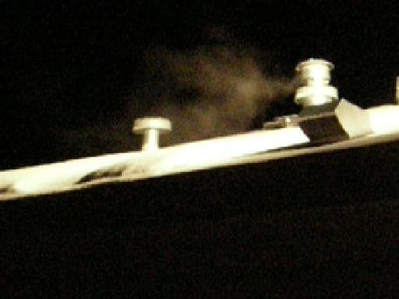
Gassing America .us !
26-34 Million in America are at risk of subtle CO poisoning in 12 million Manufactured & Mobile homes! as HUD violates OSHA, NAHB, ICC & other code!
By HUD allowing the placement of breathing-air intakes at only three feet from heating exhausts . . .
occupants are effectively placed Only Three Feet from poisoning, injury and death in HUD's Toxic Hell !

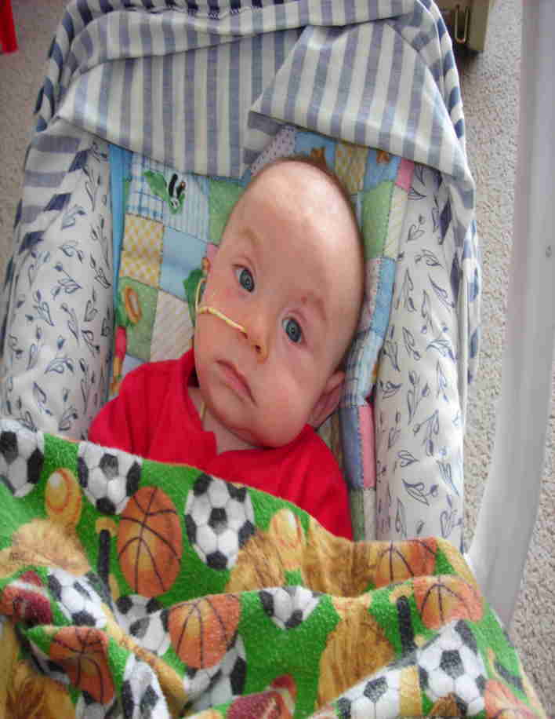
"Love Thy Neighbor!"
To save innocent lives – since after two years notice, HUD, your Government, HHS and the AMA have done nothing to correct it, – this problem requires the intervention of a loving or sincerely caring, neighbor, extended family member, or friend – like you!

This harmful, even deadly situation, which exists with some 30 million of your neighbors, their infants and families with them, can only be identified and mitigated by an unaffected, observant, clear headed, caring friend! – That is because the victims, specifically the adults in the effected households, are not always able to clearly recognize or understand their own family's injuries or their own invisible poisoning!

– And worse, in their subtle states of respired exhaust fumes hypoxia and Carbon Monoxide (CO) intoxication, their reasoning is often markedly impaired – so their sense of risk, danger, or urgency is made almost always, even fatally – compromised to non-existent! – and they do not easily recognize it!

– And It is not unusual for the responsible adults to respond in defensive denial of their own diminished mental function, coherence or reason – even denying any obvious declines in their own physical health. This denial is sadly reinforced by Medicine's currently chosen malfeasance in toxic exhaust - CO poisoning deliberate non-diagnoses within their Profession's dictums deliberated to profiteering with other, more lucrative, (mis-)diagnosis and treatments – which subsequently predisposes the cycling of the patient back to their uncorrected toxic environment, adding more insult to injury, and perpetuating even more medical dependence, mistreatment, even death!

So saving their lives, and the lives of their precious infants or their families living with them, may truly depend on genuinely loving, astute, informed and wise, functioning and courageous friends like you – armed with this truth! – So please read on!

Go to and carefully read attached papers and websites – they have already saved many lives:
GassingAmerica.us (also: PoisoningThePoor.us or LicenseToKill.us )
GassingNativeAmerica.us
DanielInTheLionsDen.us aka DeadlyFumes.us

DeseretNews.com/article/1,5143,705289487,00.html
ABCNews.go.com/Health/Wellness/story?id=6797258&page=1

CarbonMonoxideAwareness.us

Thomas L Rodgers ph 801-298-9095 Tom@TomRodgers.org tlr 5/11/10

