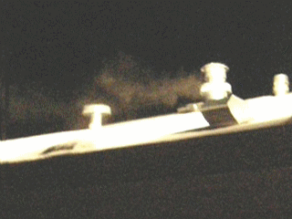
Dear Friends; HUD (& FEMA) Kills! HHS
& Medicine Covers-up! – while Human Traffickers (of Mexican slaves) Profit!

Facts are presented in full in websites:
LicenseToKill.us, PoisoningThePoor.us, GassingAmerica.us,
HUDHell.us, or ToxicTrailers.us
also GassingNativeAmerica.us, GasesMortales.us (in Spanish), and DanielInTheLionsDen.us
(Also see, print, share the attached documents: DanielFlier/LegislativeNotice, PressRelease, DeseretNews (Sunday, front page and full page following), and GassingAmerica-LoveThyNeighbor which are linked from those websites.
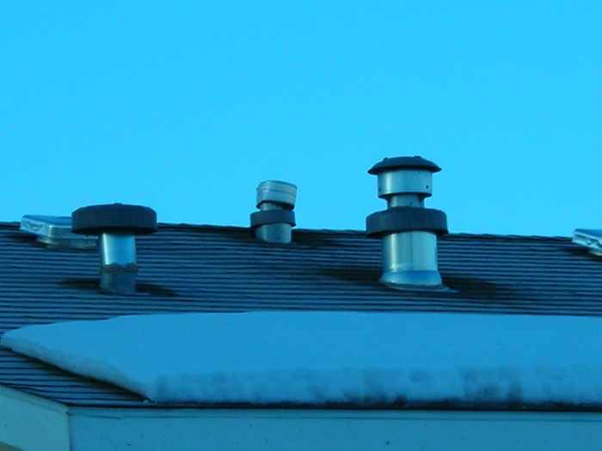
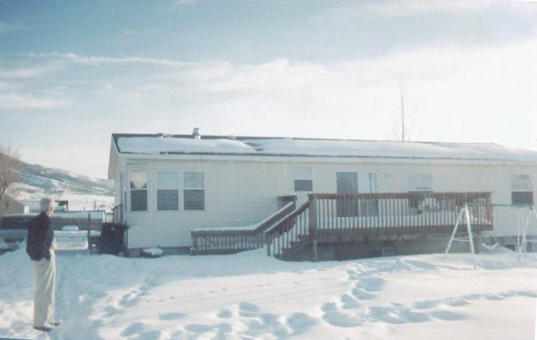
■ In Feb 2008 a rural Utah family contacted me with a deathly ill infant. As I investigated the cause of this baby’s (and his family's) illness, I discovered that they all were being poisoned in their home by a deviant venting design – the installation of a breathing-air intake only 3 feet away from furnace exhaust -- forced by HUD (w/ FEMA) upon ALL of the Manufactured and Mobile Home Production Industry, Therein I disclosed the intentional poisoning potential for 34 million in America! – that includes 26 million legal humble urban and rural folks, elderly, poor, handicapped, African-Americans - especially Katrina victims, our farming, ranching, dairy, rural labor Americans! 2 million Native Americans! – and 6 million Illegal Immigrants housed in these hazardous units while being used as cheap, "indentured" farm, dairy, ranching, slaughter and packing house and other menial jobs laborers! – all who have been losing their infants and susceptible family members or individuals for 33 years as this poisoning problem has been kept from public knowledge – with the collusion and cover of HHS, IHS and AMA! – Sound familiar? – just ask the folks in New Orleans after Katrina!
(You will also see that I was asked by an ex FEMA agent Jesse Fineran, to testify in New Orleans before EPA, FEMA, HUD and the Victims of Katrina to explain more about their injuries and deaths when they also were put in these HUD regulated FEMA Trailers. I also testified in DC (and recently in Tulsa) before HUD's Manufactured Housing Consensus Committee.)
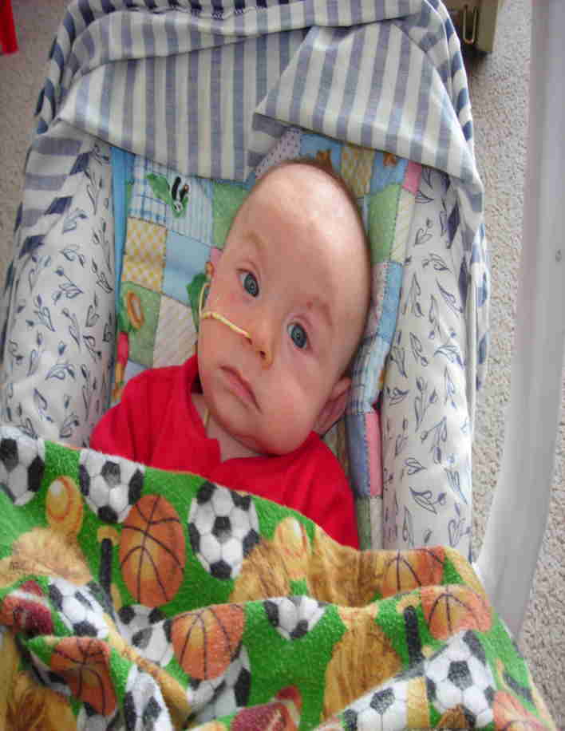
Sadly instead of receiving State and Public gratitude for identifying and disclosing this life-injuring problem in saving a failing infant and his family and potentially millions more as a consequence, I have been denigrated, mocked, slandered, called a pathological liar, had death threats, suffered assault and been made impoverished in multiple facets of my life from the beginning as I went public on this issue. In saving this precious infant and his family from HUD's poisoning problem, I did not realize I was also opening an exposure problem for our "fine upstanding" Businessmen and their housing of their illegal work-force and the "warehousing" of contraband and illicit trade that comes with that labor force (including forged documents) provided by the Criminal Syndicates and their human trafficking "Coyotes"! – But as long as babies and their families – legal or illegal – are being poisoned, left damaged, handicapped or dead, I cannot and will not quit!

Pathetically these malfeasant, even murderous Businessmen, their pocketed Bureaucrats and bought-off Medicine are willing to injure our own innocent legitimate families, including their own relatives with their infants, just to keep this housing issue silenced, so as to not draw any attention to or exposure (through identification of ownership and occupants through any safety examinations or construction corrections in their housing units) of their extortions of labor (pocketed Social Security, Workman's Comp, Taxes, etc)! – or the profitable trafficking of contraband and illicit activities in trade that comes with the undocumented individuals housed and “hidden” within HUD's Federal jurisdictionally-protected "Sanctuaries" provided for them!


This 2½ years-plus effort has cost me dearly (death threats, assaults, defamation, discredited, made impoverished and worse), but my non-negotiable honor and "pay" is in the loving embrace of a grateful mother, father and family (legal or illegal) and in the sweet smiles of their precious infant who has been saved by my exposing the truth – in spite of the evil threats and the vicious suppressions of my efforts and of those few others who have been brave enough to support me in it.

The entire United States population needs to know of this "crime" against their legitimate humble families and precious vulnerable infants living in HUD's, ignorantly or deliberately designed-to-be-toxic Mobile and Manufactured Homes (see ToxicTrailers.us, aka HUDHell.us, ManufacturedMurder.us or LicenseToKill.us)! But this fact is being suppressed to cover their real housing problem – the housing of illegal immigrant labor (along with the drugs, pornography, sex trade, etc, that too often comes with it) – and HUD's 33 years of subtly inflicted injuries and deaths! – with HHS (& IHS) cover! – Why else would this dangerous design situation, causing injuring, impairing and killing of innocent, be kept silent?

Please have all you know learn of this deviant offense and betrayal of our human family and our Public trust!

Also contact me for more understanding, or if you have further evidence and information.
– I am Thomas L Rodgers – internationally respected as the "Vegan Cowboy" Scientist (Human & Animal Pathology) (see VeganCowboy.org or VeganCowboyScientist.org), who, since my own brush with death 18 years ago, and my own survival, have honorably labored for the health, safety and sanctity of the human family, “legal” and “illegal” (including saving the Mormon Tabernacle Organist's grandchild and family – see: FamilyVsState.org and more) as you will see from my websites. Google my name and your subject.

Now go to my websites (listed above) beginning with LicenseToKill.us – also open and share the attached documents. En Espanol por favor visite: GasesMortales.us (o .com)!
Thanks, 2 Nov 2010
Thomas L Rodgers This 2½ years+ effort has cost me all I have had.
801-298-9095 Please if possible, donate a little to at least keep the
PO Box 304 Bountiful Utah 84011 websites open with this lifesaving information available.

