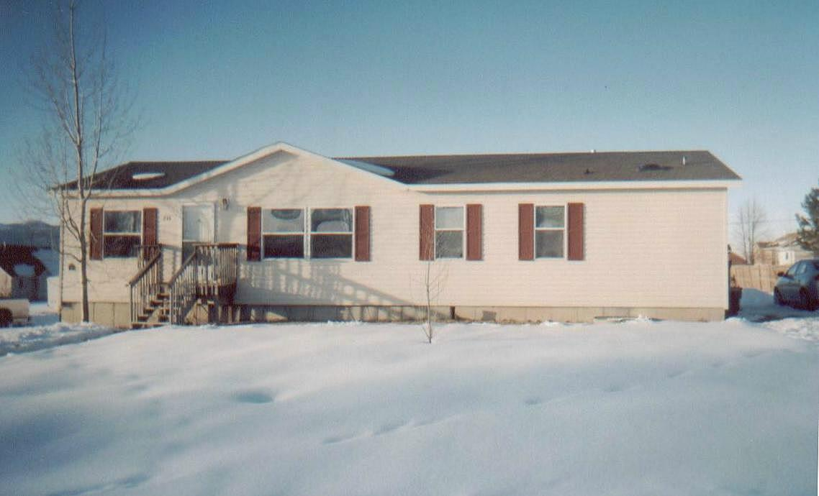
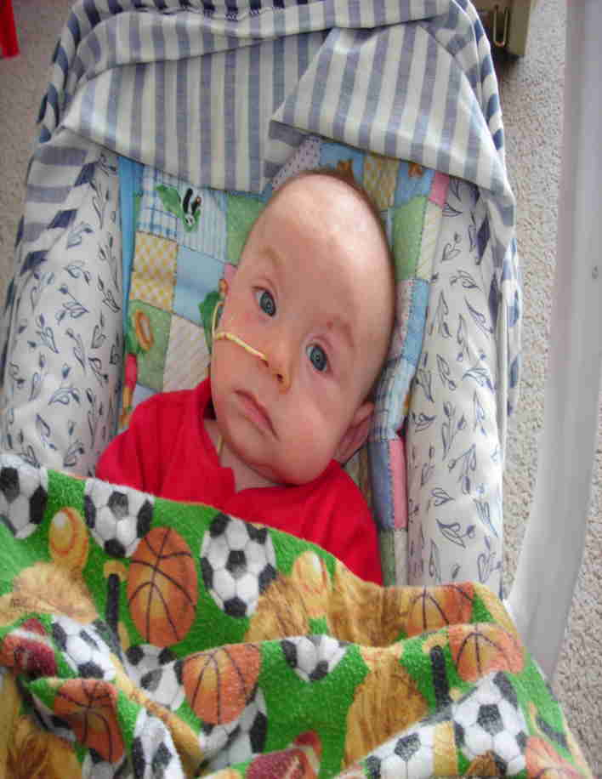
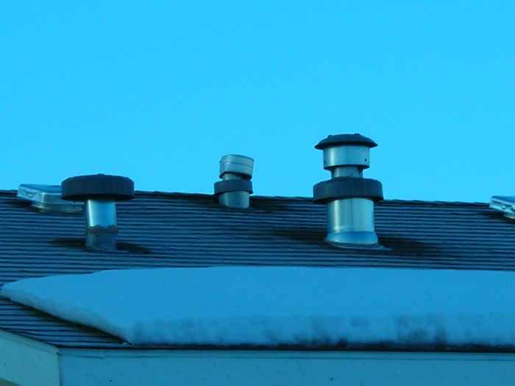

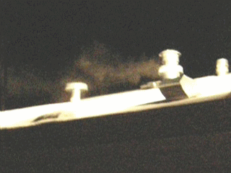
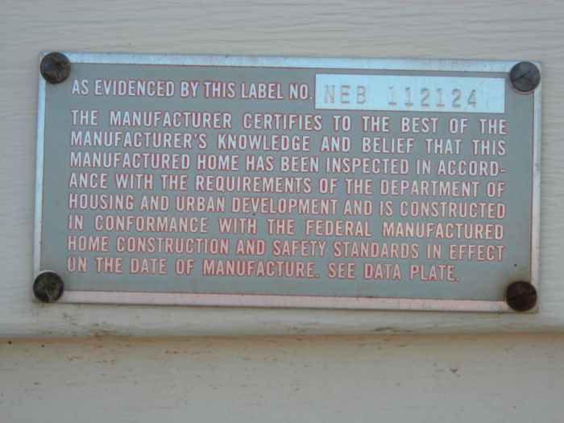
Indian & Alaskan Native Affairs Chairs and Committee Members:
Now the US GAO concurs:
Some 2 million or more Native Americans live at risk and in fact of subtle to serious poisoning through a violation of heating and ventilation code by HUD – while the resultant poisonings are misdiagnosed or left undetected in deficient diagnostic protocols of [NFPA] First Responders, HHS, IHS and Medicine!
My own (and you who have helped me, our) integrity is now verified. As a consequence, many humble innocent folks, with their precious infants and children now may have a better chance at a healthier life in their homes.
You, who have stayed true, as my humanity-caring friends and kind Washington DC facilitators, are hereby exonerated as well!
As of the (late) morning of 24 Oct 2012:
– The US Government Accountability Office, GAO, called, and finally, after my 4+ years, 4 self funded trips to DC, to New Orleans [for Jessie Fineran and his FEMA injured families], Tulsa [MHCC #2], Albuquerque, Portland and 9 western Reservations – through your friendships, efforts and influence as well – the GAO (Barry) stated they had finished their initial investigation and report (with hopes of more to come), and that I was to review and respond.
It is great to be verified! – instead of vilified! With the US GAO abilities, limits of resources and limits of co-operations, they did an excellent report! I am extremely pleased, honored and grateful!
My personal expansion on their initial report is below and on attached printable Word doc.
But please trust my WARNING; as you know already, my sorrow and pain for the victims and my rage for the perpetrators and those who should have prevented it, always bleeds through! That is me, even in my pragmatic, exacting science mode, or best political or public behavior, I blast the inept or malfeasant – take it or leave it. But remember that same provocative drive and lifesaving covenant fixed within me, even at the price of my own reputation, comforts and safety, is what has made this all happen! – In this I do not apologize and believe I can stand blameless before my Creator – and before His precious little ones, who many I already have saved – and more, hereby, can and will be saved!
Please open the U.S. Government Accountability Office's website GAO.gov and click on their report at top of their homepage (at this date) called "Manufactured Housing Standards", it will open to a brief overview. Then click on the PDF link (at top) to Full 34 pg Report.
Note references to (my) testimony of the "Utah" case (before the MHCC, July 2009) on pages 2, 9 & 10, with my continuing evidence and disclosures to MHCC, the Senate. Executive, Judiciary Branches, Congress and other effecting Agencies, which provoked and initiated this (GAO) investigation and irrefutable report.
Notice on page 10 the (since the late 70's, the deliberate) failure in NFPA (and CPSC) "First Responder" guidelines, and in HHS (AMA, IHS) directed Medicine in all States to affirmatively (not) immediately blood-test-for, (nor) immediately (in a timely manner, if at all) clinically pursue, diagnose, treat, report or maintain a registry of Carbon Monoxide (as well as Formaldehyde or the other combustion, construction or gluing VOCs) poisoning events in residential or Manufactured and Mobile Home occupancy events or cases – so HUD (with First Responder and Medical complicity) claims there is none – except for my case(s) in Utah.
So please suffer more with me now as I must become tediously technical:
I guess we in Utah (and specifically, only one family in Utah) are in the only State in this entire Union to have any snowstorm accumulation deep enough (8 to 18 inches) to have thermal or barometric scooping, channeling or (at 18 inches or more) covering and "cavitating" both exhaust and breathing (dilution) air intake vent flows ultimately "tunneled" together in one single snow cavity (not discussed or factored into the GAO report in ASHRAE's good, but narrow-input test – since they did not utilize the always-beneficial professional humility, enough to consult with me, the original and long experienced source, or review thoroughly or carefully enough, all my evidence, facts and factors, disclosures and data, to duplicate, refute or establish all possibilities), But I am sufficiently certified anyway, even in their basic 3 foot test separation (duplicating the HUD mandated standard) wherein ASHRAE obtained 50 ppm CO; and that exceeds OSHA's human exposure limits in a single 8 hour workplace environment, as opposed to the 24 hr 7 day, everyday exposure a fetus in-utero or infant (who begins injury at much less than 20 ppm), or toddler, handicapped, house-bound or elderly risks "under HUD's roof" in their Manufactured or Mobile home! – or for others in Units used in Federal, State, BLM, Military or commercial field operations, as administration offices, service, warehousing and/or billeting).
We (in Utah and all other fridged-weather States) also must deal with our dead quiet cold where carbon-compound-dense exhaust toxins experiance immediate thermal loss and "fall-back", even if exiting a flue cap assembly is elevated 3 feet (as ASHREA also simulated, still obtaining fetal and infant killing 30ppm when sustained – even without the brute cold thermal-loss and fall-back factors of our fridged States, which "fall-back" factor easily restores intake CO to or exceeding their initial HUD model contamination level of 50ppm at current jack heights (~8-18 inches, per HUD), as the exhaust quickly loses its thermal lift in dead silent air (no wind), drops back and accumulates at the roof, or snow surface and breathing (dilution) air intake height and proximity, to be easily power-drafted in by the strong negative pressure draw at ~30 to 90 cu ft/min. – And this event, per HUD records, only has occurred only once (my case), in one home, in one city, and only in Utah?– and only once in 33 yrs? – So I am insane? Is the GAO, ASHRAE, and OSHA by extension, insane with me? while HUD w/FEMA, NFPA, HHS and IHS are not???
– Try telling that HUD-contrived, HHS-complicit "no-injury-reported" BS to the Katina FEMA Trailer and HUD Park Model Units placed victims (for who I also testified in New Orleans) with their CO, H2CO, VOC violate glues, construction materials and combustion exhaust (including cooking and sewer) gases asphyxiated dead or barely surviving brain or systemic, lifetime damaged family members!
Not one family (that I know of) in the Gulf Coast event was told of the presence of those Trailer-sourced toxins in their blood streams or in the blood or deep tissues of their dead (until Jessie Fineran and Becky Gillett's Sierra Club funded and facilitated testing) – because the victims were deliberately never serum (toxin) tested – or reported – under their Federally (HHS) managed Katina-aftermath Medicine.
– That silence worked perfect to prevent the billions in liable suits that should have been claimed from HUD and FEMA's pathetic incompetence and consequent malfeasance in regulation and testing! – and isn't this exactly what this report exposes! – And this is the same Agency expected to "safely" (aaccording to what their little aluminum tag says) house the "17 million" permanent residents in Manufactured and Mobile homes, or even you temporally through a calamity like Katrina [now Sandy] again?
They cry short funded? I don't buy it! In 4 trips to DC, in HUD's massive, extravagant fortress in DC. I spent over 4 hours waiting, each time – no-one showed, though hundreds of well-dressed employees and well-dressed "clients" [contractors] passed by me, multiple days nothing happened!
The same with HHS! (Its the same useless parasite mentality infected DC BS!
– For 33 years their joint apathy has been killing babies and injuring innocent families! while extracting healthy commissions and retirements for it!)
Print the excellent GAO report,
Reference my name, phone number and the http://LicenseToKill.us and distribute to those who advocate for our Manufactured and Mobile Home occupant families safety and their well being!
I will gladly fill in where ASHRAE's excellent but limited test model for the GAO could not,
My thanks to supportive Congressmen Moran and Olver, to ASHRAE, and especially to the dedicated and diligent GAO team!
Others of Congress and beyond also worked (often anonymously) to open doors for me!
There are some very good men and women in DC who, sharing my same faith and values, do care for the people they are charged to protect. I want to keep them though other constituents (not understanding DC 38) do not know that "Righteous Tenure" is the only way to mitigate DC's entrenched "Evil Tenure".
It worked here! Ask me sometime, one on one, if you wish).
Indian Affairs Committee Members: Please discuss this issue with the NCAI Leadership and Tribal Representatives in the remaining opportunities of this week, as well as in any subsequent meetings or follow-up communications with you.
Thank You!
Thomas L Rodgers
801-298-9095
http://LicenseToKill.us
(This provocative domain name was chosen because of the little aluminum "License" [tag] installed on every Manufactured and Mobile Home unit since June 15, 1976, "assuring" the occupants that they are safe in the jurisdiction of HUD, NFPA's-MHCC and FEMA, coupled with their presumptuous trust in the "license" of Medicine, HHS and IHS – while they are being poisoned! and never told!) TLR 4 Dec 2012

