Legislative / Public Notice:
Re: GassingAmerica.us / DanielInTheLionsDen.us also GassingUtah.us / GassingNativeAmerican.us 19 May 09

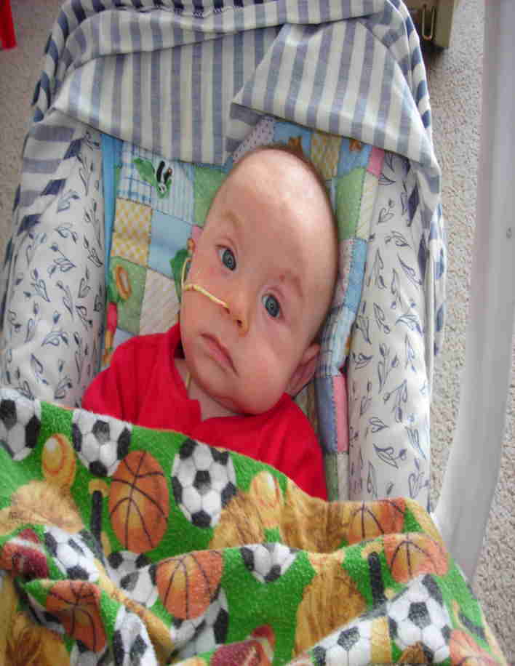
On Feb 10 last year, 2008, a family in Manti Utah with an ill infant, and under DCFS threat, contacted me. The Doctor in their community did not identify the actual cause. The family knew I had experience dealing with the State and success in pediatric forensics and pathology. In 3 days, after they were referred to PCMC hospital locally, I was able to see the child and his parents. I realized by their appearance and behaviors that all three, the infant as well as the father and mother had been poisoned. In 6 days (during legislative weekend break) I was able to travel to their home. I discovered the family’s actual poisoning cause! -- Carbon Monoxide was entering their home!

There was nothing wrong with their furnace or any other combustion type appliance.
The source of their poisoning was a decades-ago Federal (with State and Medical complicity), “carefully deliberated”, HUD established and dictated construction and installation code (as a true lunacy), which allows exhaust fumes to easily enter back into their manufactured and mobile home units, when positioning and certain common, periodic or severe weather patterns exist.

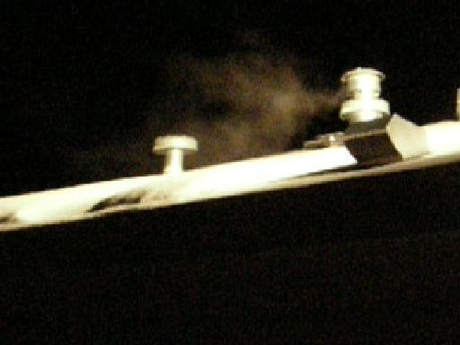
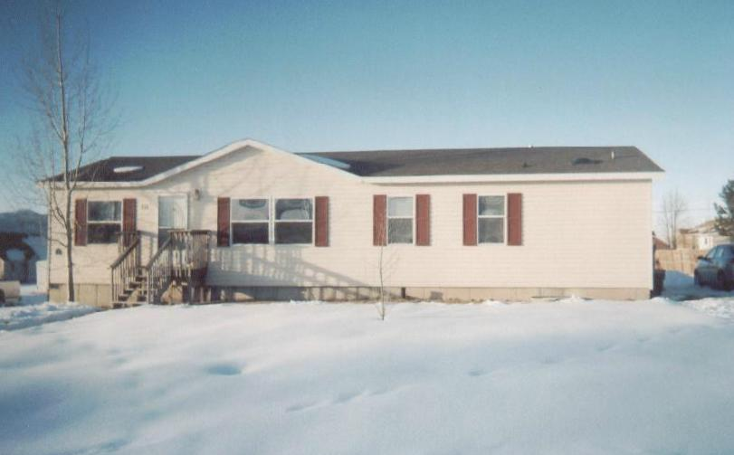
For 3 decades HUD has put at risk over 26 million residents as it has defied all other rational community building standards and code setting entities -- as well as ignoring well understood environmental and biological sensibility and fact, by allowing in Mobile and Manufactured homes, a separation distance of only 3 feet (as opposed to 12-14 ft) from a furnace, water heater, or sewer exhaust to a passive or power driven fresh air intake, aka “supplemental air”, “blend air”, or “Dilution air” intake vent. This “fresh” air intake was intended to compensate (via fan forced supplementation) for the oxygen consumption of the occupants inside these generally air-tight constructed and smaller total interior air volume situations extant in HUD designed, regulated and “inspected” Manufactured and Mobile home type units.

This poison-affected infant and his family’s home was one of those HUD “certified as safe” Manufactured / Mobile home type units -- just like those constructed and used to house and injure the Hurricane Katrina victims.

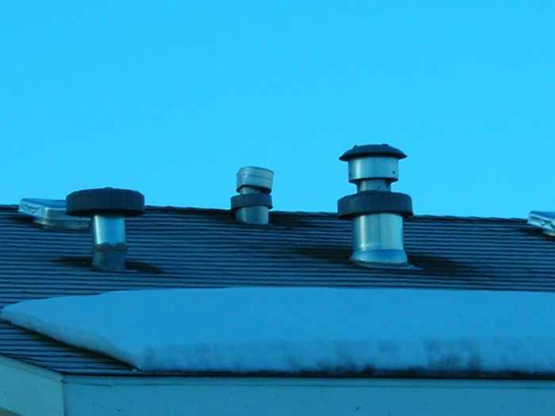You have heard the reports of the formaldehyde poisonings experienced by those occupants in those “Katrina” units. Through the poisoning discovery in this family’s case, I opened the far greater Pandora’s box of hidden and unidentified Carbon Monoxide (CO) injuries and deaths occurring in these offending units for nearly three decades at the malfeasant or incompetent regulatory hands of HUD (and now FEMA).

Locally and Nationally, millions of individuals living in these units have been unknowingly harmed by this design-created back-draft of toxic exhaust from their heating systems, especially in last and this current winter’s unusually severe cold and wind patterns. Still left uninformed they are subject to further harm and deaths in this winter’s already extant, continuing and further anticipated severities.

Sadly for fifteen months I have been deliberately obstructed, stone-walled, denigrated, abused, threatened and injured, reputationally, professionally, politically, socially, economically, and ecclesiastically, by those invested with position and power that are unscrupulously benefited and profit from the unique cheap (many undocumented) labor supply, or from the struggling and vulnerable low income people who generally live in, or are housed (and as now understood, consequently made ill and left with injury) in these inexpensive (cheap to purchase, transport and set) “local inspection / local government entry exempt” HUD (Pre-) Manufactured and Mobile Home type housing units.

Clearly no (cheap-labor) benefited businessmen, HUD (or FEMA), the Bureaucracy, their contractors, distributors, beneficiaries, or the opportunistic Medical community, want to have these (now millions of) units investigated and have the often illegal nature of many of their occupants discovered or their injuries disclosed – not even to let those other legitimate individuals and families living in them understand and protest over the injuries and deaths which they have experienced for over several decades without ever being informed as to the true cause of their injuries or deaths; or to have the costly discovery, correction, litigation and recompense made for the tens to hundreds of thousands of injuries and deaths so caused. This is why you have heard NO disclosure in the mainstream news.

Until Government acts, occupants must be informed and abled to protect self & family from this poisoning harm.
Learn at GassingAmerica.us or GassingUtah.us, -- videos, photos, documents, etc on DanielInTheLionsDen.us

Thomas L Rodgers, Phone: 801-298-9095, LSI, PO Box 304, Bountiful, Utah, 84011 (email Tom@LifeSave.org)

