Press Release 13 Feb, 2010 (original was written and distributed 1 Sept 2008)
GassingAmerica.us! (PoisoningThePoor.us & ThreeFeetToHUDsToxicHell.us)

Notice and Warning! to all Residents and Persons residing in the United States (including Tribal Communities, Military, DNR, Canada, Mexico, etc)
– and living in Manufactured or Mobile homes! – all created, manufactured, regulated, inspected, certified and distributed by the United States Federal Housing and Urban Development Agency – commonly known as HUD!

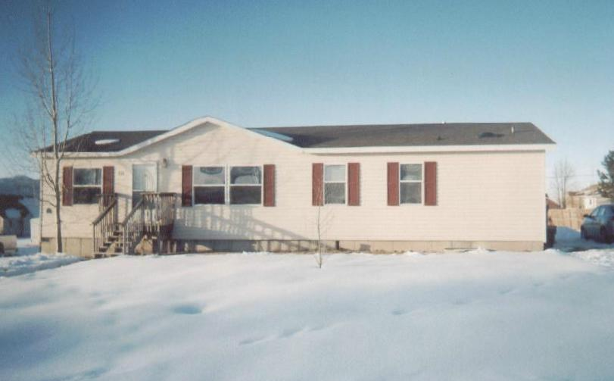
While State and Community Inspection has relinquished critical oversight - HUD has created and established construction codes and practices that have and do presently endanger the health, safety, and well-being of most all Manufactured (Mfd) and Mobile (Trailers) home unit occupants.

It appears that for the sake of saving initial construction materials, labor costs, and transportation convenience, for 33 years, HUD has chosen to ignore common sense and standards of safety, which has been long and wisely established by other experienced and well respected construction code setting entities and agencies, such as the National Association of Home Builders (NAHB), the International Codes Coalition (ICC), NFPA, NIOSH, OSHA, IRC, etc., as well as all other code and inspection bodies at local, state, federal or international levels.

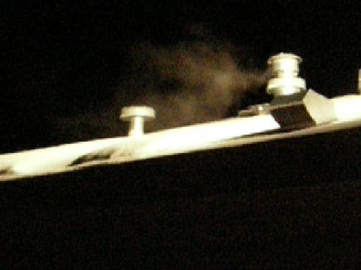
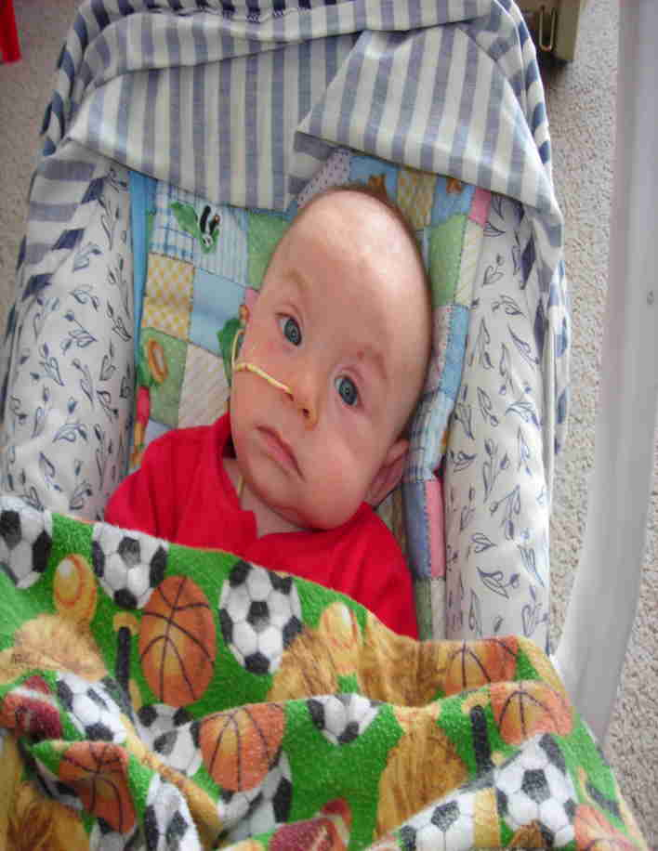
By so doing, HUD has predisposed and caused illness, harm, biological and neurological injury, transitory and permanent damage and deaths to thousand of unaware, unwarned residents in their so-called “certified as safe” Mfd/Moblie home units.

All other Construction Standards and Codes setting and Inspection providing Agencies, affecting the interior heated and air conditioned air quality, have set their minimum separation distances for supplemental breathing air supply openings or fresh air intake vents (powered or natural draw) to any combustion exhaust, sewage, or other harmful vapors outlets to be at least 12 to 14 feet (exception being 10 feet min allowed only in restrictive industrial constructions, and that is only acceptable as long as all other conditions prevent that reduced distance from presenting a nuisance or hazard) – while HUD has instead chosen to set and /or permit their separation distance construction standard or code to be allowable at as little as only 3 feet!

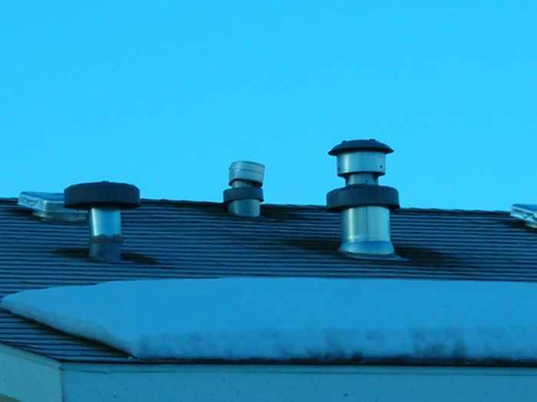Also, all other Construction Standards and Code setting agencies require all exhaust and intake vent stands (aka stacks or jacks) to have a rise or elevation (height) above roof surface to exceed anticipated or potential snow lay for the resident community; and to prevent vapor pooling by requiring vent exits or intake ends to generally be above the ridge line of adjacent roof or other wind flow obstructions – which, in most cases, puts the exhaust and intake vent stack elevations at at least 2 to 4 feet above roof surface – while HUD simply allows the minimum height of the flange (or roof jack) and the cap assembly itself to serve as its rise requirement – which usually (combined) is only 6 to 18 inches high.

So while ALL other agencies have wisely and rationally set separation distances between exhausts and intake air usually at 12-14 feet (10 feet min. per ICC) and elevation or rise heights at usually 2-4- feet, HUD insanely allows vent separation distances of only 3 feet, and elevations (rise) of only 6-18 inches! This deviation from long established physical and biological reason creates multiple operational and occupant poisoning problems! (See operational and resultant occupant poisoning problems explained and displayed [or linked] in website: DanielInTheLionsDen.us, aka DeadlyFumes.us.)

HUD’s design flaw allows for the easy potential and perpetual poisoning of all Manufactured and Mobile housing occupants with all combustion produced toxins – specifically Carbon Monoxide (CO), as well as combustion created Formaldehyde (H2CO), Sulfurous and Nitrous compounds and all other toxic combustion exhaust compounds – and in the case of HUD’s equally allowed short and closely adjacent sewer vents – hydrogen-sulfide, ammonia, methane, etc, are also often easily drafted inside.

This egregious design and inspection error, 3 decades ago established and allowed today by HUD, has and still does presents a serious health and safety hazard, causing harm, illness, transient and permanent physical and neurological damage, impairments and death to many HUD housing occupants – specifically infants, toddlers (with their developmental high oxygen demands), followed by their attending adults, the aged, handicapped, the already infirmed or otherwise “house-bound” occupants.

In the News you have been made aware of the Hurricane Katrina victims currently demonstrating “Formaldehyde (HCO) poisoning” illnesses associated with them living in HUD regulated units secured by FEMA. – Their poisonings represents a small part of the poisoning harmed victims created by HUD’s egregious Heating and Air Conditioning (and Sewer) venting and construction “safety” design errors!

Facilitating this heinous human damage situation, created by HUD, is the intentional avoidance by AMA Medicine and HHS to test for and identify the Carbon Monoxide in the blood of the affected occupants. – Instead they are suppressing this egregious, greatest in prevalence, number one poisoning event! – This allows for enormous profits in Medicine, by instead, treating the victims for everything else except Carbon Monoxide (CO) poisoning (see symptoms and misdiagnoses listed in website linked herein) – while also conveniently shielding HUD (the Federal Government), its Contractors and their Investors from any liabilities and lawsuits in their 30 years long established negligence, committee deliberated, malfeasantly designed, harm affecting America’s lower income, displaced, destitute and poor, including her African Americans, Native Americans, aged, retired, widowed, handicapped, students, Missionaries, rural Clergy, Veterans, County, State and Federal Officers and Field Agents, our precious selfless Military, and thousands of Mexican Nationals or other cheap immigrant labor and other transient, temporary or “disposable” families and individual Manufactured and Mobile home occupants!

Other perverse and profiting opportunities are presented in the ignorance and cover-up of this poisoning issue, as the innocent occupants and victims are more likely to be wrongly charged with negligence, abuse, even homicide, by incompetent or malicious Medicine in collusion with Child Protective Agencies and other agencies of the State or “Law”. – So many more of their children are removed, trafficked, or adopted out, while the innocent victimized occupant families or individuals are wrongfully destroyed in this bureaucratic incompetence, malfeasance or fraud, which appears focused more often upon these limited resource, often underprivileged, hence generally defenseless residents and occupant victims.

– This undue harm to innocent Manufactured and Mobile home unit occupants includes the unreported, often untreated injuries, illnesses, impairments and deaths in this housing of illegal aliens through the ownerships of many Manufactured and Mobile (ie. HUD “protected” as jurisdictional sanctuary) units by unscrupulous businessmen to house (hide and control) their cheap, under or unreported (extorted) labor!

No mother, father, family or person, legal or illegal, deserves to suffer the poisoning injuries themselves or the death of their infants or loved ones at the amoral hands of HUD and its profiting collaborators!

To see exactly how (in photos, video and explanatory text) HUD’s Heating, Air Conditioning and Supplemental Interior Environmental Air construction code flaw allows illness, harm and death to their units’ occupants – go to GassingAmerica.us (PoisoningThePoor.us , ThreeFeetToHUDsToxicHell.us )

Follow through to the technical, operational and performance data, and an individual victim family’s experience, and learn what you must do! in DanielInTheLionsDen.us or DeadlyFumes.us

See a do-it-yourself, no-cost temporary solution to protect yourself and your family, right now!

Questions or further information:
Thomas L. Rodgers, LSI
PO Box 304, Bountiful Utah 84011-0304 Ph. 801-298-9095 Email: Tom@LifeSave.org

