Public Notice:
Re: GassingAmerica.us, aka ThreeFeetToDeath.us or HUDsToxicHell.us 26 Nov 08 (.us)

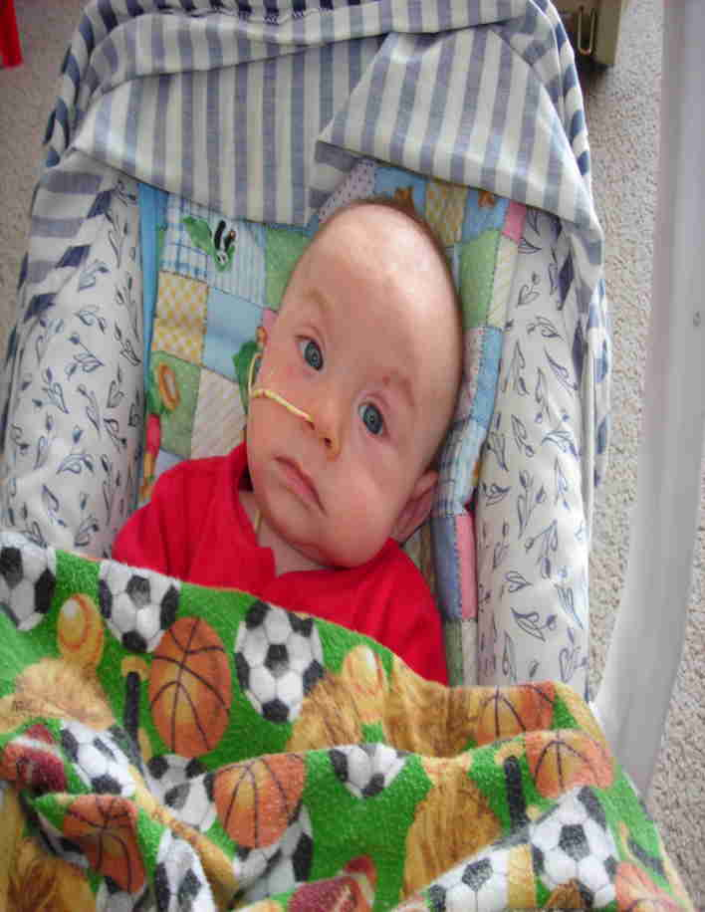
In February of this year, a family 140 miles from me contacted me with a deathly ill infant. The doctors and clinic in their community did not identify the actual cause and the family knew I had experience and success in pediatric forensics and pathology. Within three days (as they were referred to a local hospital) I was able to see the child and his parents. I realized by all of their appearances and behaviors that all three (the infant, as well as the father and mother) had been poison damaged. Then, in 6 days (after a local legislative weekend break, I was able to travel to their home) I discovered their actual poisoning cause: Carbon Monoxide was entering their home!

There was nothing wrong with their furnace or any other combustion type appliances.

What I did discover as the source of their poisoning was a decades-ago “carefully deliberated” long established HUD code, construction and installation design standard (a true lunacy), which allows exhaust fumes to easily enter the home when periodic, common or severe weather patterns exist.
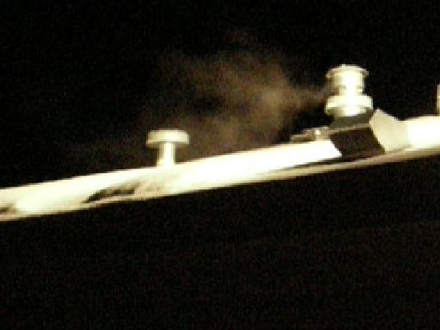
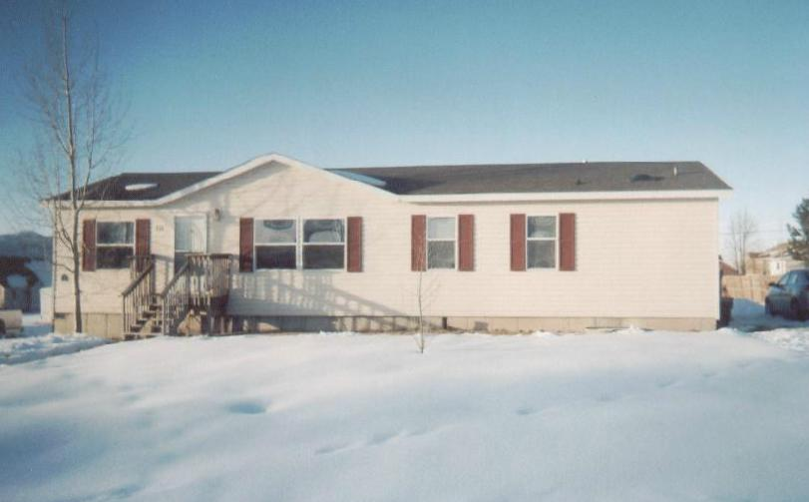
HUD somehow has defied all other code and building standard setting entities or agencies and gotten away with ignoring common sensibility, environmental and biological facts, so allows a separation distance of only 3 feet from a furnace exhaust to a passive or power driven fresh air intake, aka “supplemental air”, “blend air”, or “delusion air adder” intake vent, to bring in and add “fresh” outside air into the interior occupant breathing air – in theory to supplement the oxygen consumption of the occupants in the generally air-tight construction and smaller total interior air volume situations of these HUD designed and regulated “certified as safe” Manufactured and Mobile home housing units.

This family’s home is one of those HUD Manufactured and Mobile home units exactly like those constructed and used to house the Hurricane Katrina victims.

You have heard the reports of the poisonings experienced by those occupants in those units. Through my discovery in this family’s case, I opened the far greater Pandora’s box of Carbon Monoxide (CO) injuries and deaths occurring in them for over two decades at the hands of HUD (and FEMA).

Nationally, millions more individuals and families living in these units have been harmed unknowingly by the back-draft of toxic exhaust from their heating systems in this last winter’s unusually severe cold and wind patterns; and still left uninformed are about to be further harmed in this coming winter’s anticipated severities.

Yet for nine months I have been deliberately obstructed, stone-walled, denigrated, abused, threatened and injured, reputationally, professionally, politically, socially, economically, and ecclesiastically, by those invested with position and power and are unscrupulously benefited and profit from the unique cheap (many undocumented) labor supply, or the struggling and vulnerable low income people who generally live in or are housed (and now understood, consequently are made ill and left with injury) in these inexpensive (cheap to purchase, transport and set) “local inspection and local government entry exempt” HUD (Pre-) Manufactured and Mobile home type housing units.

Not one of the benefited business owners, HUD (or FEMA), the Bureaucracy, their contractors, distributors, beneficiaries, or the opportunistic Medical community, want to have these (now millions of) units investigated and have the often illegal nature of many of their occupants discovered, or their injuries disclosed – or ever let those others who are legitimate individuals and families living in them understand and protest over the injuries and deaths they have experienced for over two decades without ever being informed as to the true cause of their injuries and deaths; or to have the costly discovery, correction, litigation and recompense made for the tens to hundreds of thousands of injuries and deaths they have caused. This is why you have heard no warnings in the mainstream news.

Please learn more at GassingAmerica.us, aka ThreeFeetToDeath.us or HUDsToxicHell.us,
Then follow links to videos, photos, documents, etc on DanielInTheLionsDen.us aka DeadlyFumes.us.
You must act to protect yourself and your family from this poisoning harm. Please feel free to contact or call!

Thomas L Rodgers,
Phone: 801-298-9095
LSI, PO Box 304, Bountiful, Utah, 84011-0304, (email Tom@LifeSave.org)

