Your Mobile Home may be Poisoning you and your family! 6/27/10
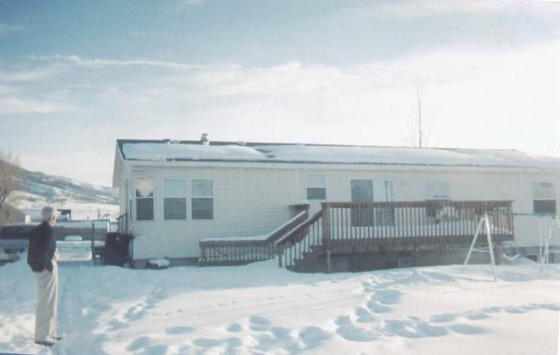
Because of HUD regulations, your Mobile or Manufactured home is potentially poisoning you and your family!

All gas, propane, oil, (pellet or coal) heated Manufactured homes, created since 1976, violate safety codes, since HUD took over and ordered the entire Mobile and Manufactured home industry to place a Breathing Air Intake (also called a Dilution Air Intake) on the roof, only three feet away from the Furnace Exhaust!

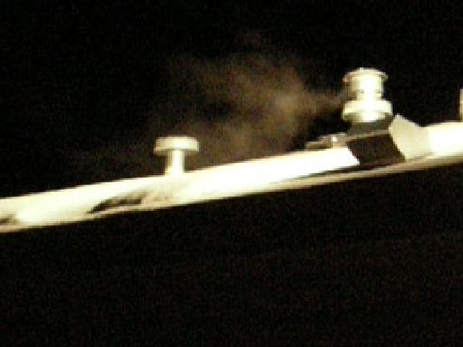
So when the Winter air is motionless or the breeze is the wrong way, fumes from your Furnace are sucked into that Breathing–Air Intake and mixed into the air you breathe inside your home!

Sadly, about the same time HUD forced this violation of safety, the common testing for Carbon Monoxide (Formaldehyde and other VOCs) was dropped from “Best Practices” or Standard Diagnostic Protocols, in both White American and Native American provided Medicine.

Thousands of injuries and deaths among the humble and poor have gone misdiagnosed, unidentified, unreported , uncorrected and uncompensated-for as a consequence!

But you can easily protect yourself and prevent any more injuries and deaths when you understand the problem! And you can cheaply fix the problem when you know what it is.
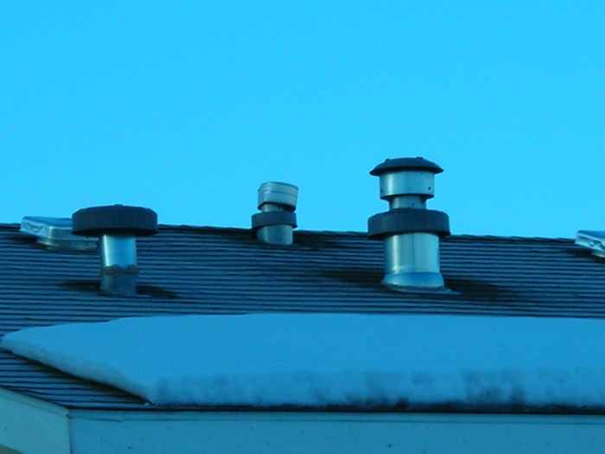
On your roof you will see several pipes. First notice your Furnace Exhaust – it will usually have two caps (like pipe at the far right >) and be warm (or hot). A Water Heater exhaust, (also warm or hot) may be nearby. You will also see a similar pipe with a single cap only three feet away (like the pipe at left) – it will always be cool (except when the Sun makes it hot), – that is the Breathing Air intake! Simply place a plastic garbage bag upside down to cover its cap (and opening under it). Tape or tie bag tightly around pipe so that NO more Furnace (or Water Heater) exhaust fumes can be sucked threw it into your home to hurt you or your family any more.

Then be sure to open a window or two just a little bit to allow some fresh air to enter.
– Immediately notify Tribal Leadership including your Tribal Housing Authorities.
– Also notify Larry Echo Hawk, BIA, NCAI, etc, State Governments and every Bureaucrat (and Doctor) responsible for your family’s safety. (But be ready for their denial of harm.)
– Also ask your Tribal Medical Providers to start properly testing for Carbon Monoxide (and the other combustion created poisons, including Formaldehyde) in your own, your infant's and your family’s bloodstreams, every visit. It is cheap and easy for them to do.

See GassingNativeAmerica.us , PoisoningThePoor.us, or LicenseToKill.us
Please share this knowledge with your family, neighbors, work associates and friends!
Please know I would be honored if you would also tell me of your experience or situations. – Your experience helps me when I am testifying before Government and Tribal Leaders.
Thank you. Thomas L Rodgers, Tom@TomRodgers.org. Call me anytime: 801-298-9095

